- Common solids
1. Below is a net of a model of a 3 – dimensional figure. The lengths AB = BC = AC = 6.0cm and lengths AF = FB = BD = CD = CE = AE = 8.0cm.

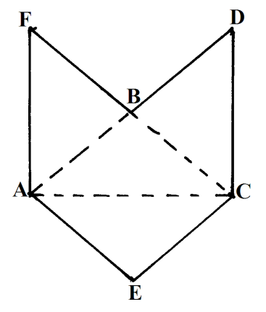
a) Sketch when the net is folded by taking ABC as the base and the height 5cm.
b) State the name of the figure sketched (3 mks)
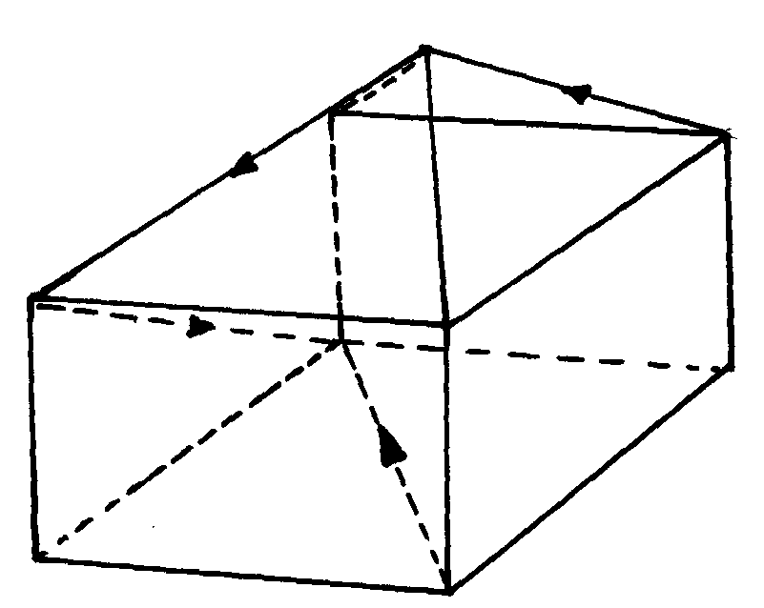
2. The figure below represents a square based solid with a path marked on it
A
D
J
H
C
E
B
G

Sketch and label the net of the solid *
3. The below shows a solid prism:-
10cm
6cm
7cm
5cm
E
D
F
B
C
A

(a) Sketch the net of the prism above
(b) Use the net in (a) above to calculate the total surface area of the material used in making
the solid

4. Draw the solid whose net is shown below.

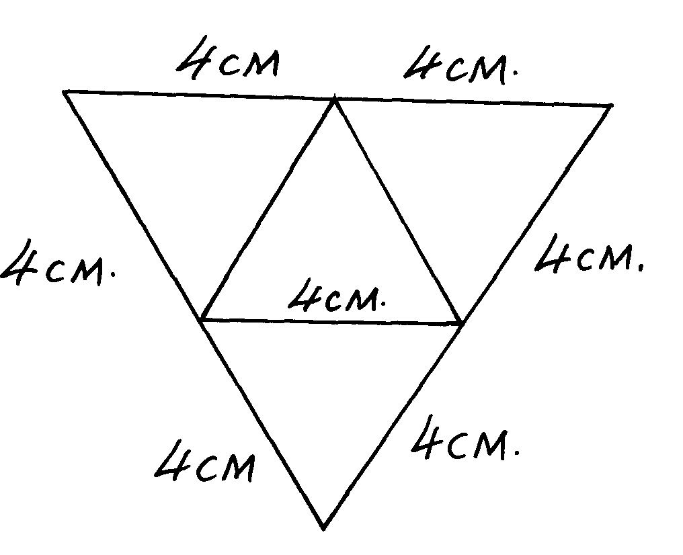
4cm
4cm
4cm
4cm
4cm
4cm
4cm

4cm 4cm

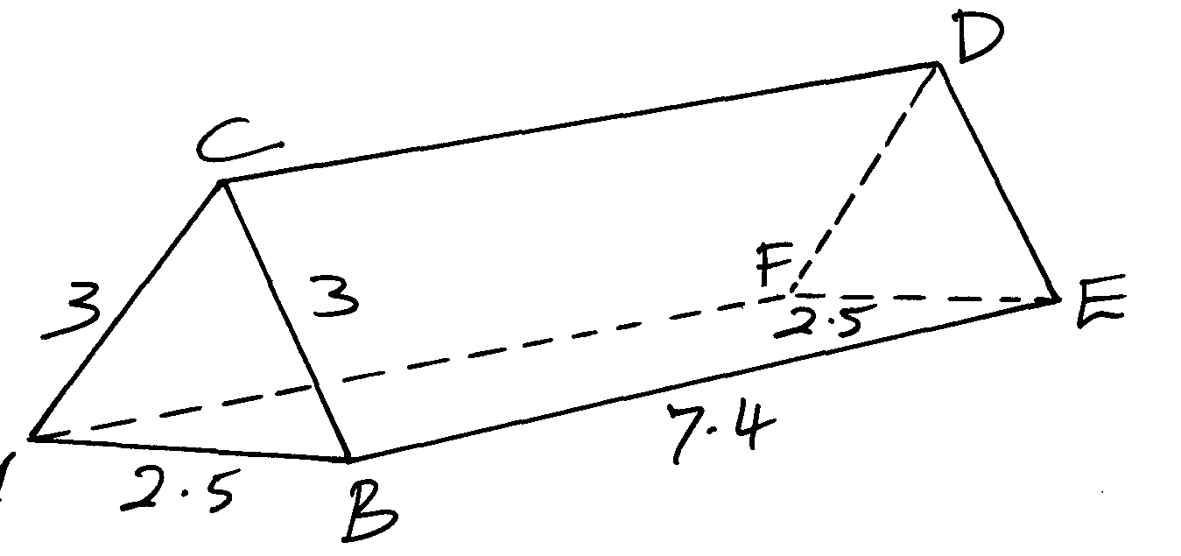
5. Sketch the net of the solid shown in the figure below, measurements are in centimeters
A
2.5
C
3
3
B
7.4
D
E
F
2.5

